CSV FILE: train.csv

Q1- Set PassengerId as the index.

Ex Ans:

|  | **Survived** | **Pclass** | **Name** | **Sex** | **Age** | **SibSp** | **Parch** | **Ticket** | **Fare** | **Cabin** | **Embarked** |
| --- | --- | --- | --- | --- | --- | --- | --- | --- | --- | --- | --- |
| **PassengerId** |  |  |  |  |  |  |  |  |  |  |  |
| **1** | 0 | 3 | Braund, Mr. Owen Harris | male | 22.0 | 1 | 0 | A/5 21171 | 7.2500 | NaN | S |
| **2** | 1 | 1 | Cumings, Mrs. John Bradley (Florence Briggs Th... | female | 38.0 | 1 | 0 | PC 17599 | 71.2833 | C85 | C |
| **3** | 1 | 3 | Heikkinen, Miss. Laina | female | 26.0 | 0 | 0 | STON/O2. 3101282 | 7.9250 | NaN | S |
| **4** | 1 | 1 | Futrelle, Mrs. Jacques Heath (Lily May Peel) | female | 35.0 | 1 | 0 | 113803 | 53.1000 | C123 | S |
| **5** | 0 | 3 | Allen, Mr. William Henry | male | 35.0 | 0 | 0 | 373450 | 8.0500 | NaN | S |

**Q2. Create a pie chart presenting the male/female proportion**

Ex Ans:

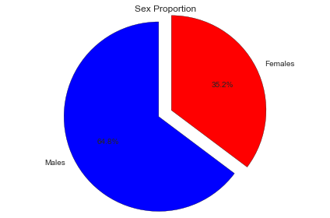

Q3.Create a scatterplot with the Fare payed and the Age, differ the plot color by gender.

Ex Ans:

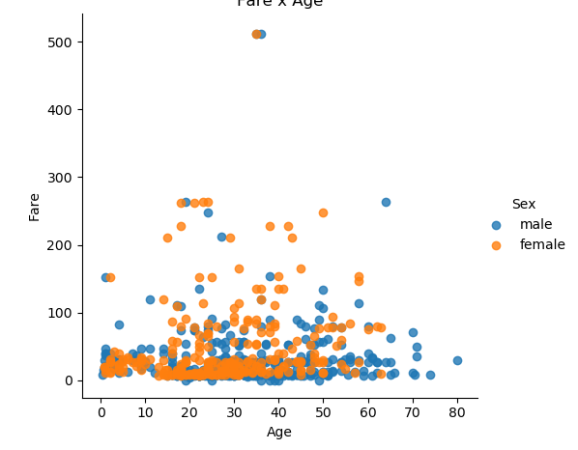

Q4. How many people survived?

Ex Ans: 342

Q5.Create a histogram with the Fare payed.

Ex Ans:-

